
Thanks for your interest in joining the Sign fitters Directory. The sign fitters directory's aim is to aid signage companies by helping them find sign fitters across the U.K and Ireland. Sign makers often need to outsource work for many reasons. It may not feasible for their fitting crews to travel across the country to a job or they may be too busy and are looking to offload some work. This directory helps connect the two companies.
The directory is free to join, all we ask in return is a link from your website back to either the directory page or the Brownings home page. All details are listed below, if you could fill in the below details and e-mail them back to: Brad@browningsltd.co.uk. Once we have the completed form and the link is live on your website then we will add your company to the directory.

Submission:
There is no charge to be included in the Directory all that’s required is a “Dofollow” link from your website to either the Brownings home page or alternatively direct to the directory page. The link can either be a simple text link or by using one of the images below (high res images available on request). This is something your webmaster will be able to do with relative ease.
Once the link is live, please e-mail Brad@browningsltd.co.uk to inform us along with this completed form and we will add your company to the directory.

Link to us either by a simple text link or by using one of the below images:

Links:
Brownings home page: https://browningsltd.co.uk/
Directory page: https://browningsltd.co.uk/directory

Please see the next page for the application form.

Application form:
Company name:
Address:
Tel no:
e-mail address:
Website:

Areas covered (please highlight covered areas):
A. UK
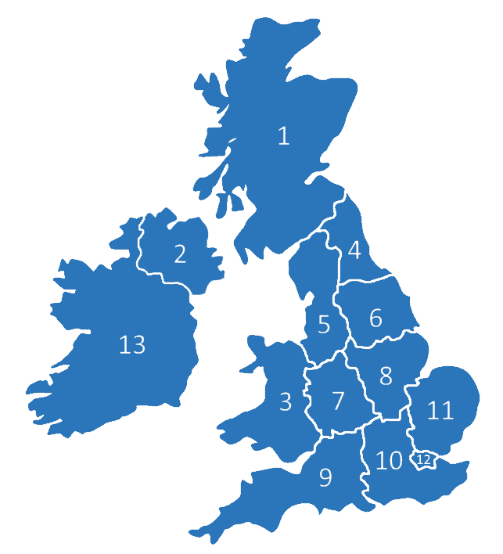
B. UK & Ireland
1. Scotland
2. Northern Ireland
3. Wales
4. North East
5. North West
6. Yorkshire and the Humber
7. West Midlands
8. East Midlands
9. South West
10. South East
11. East of England
12. Greater London
13. Ireland

Thanks
Brad Robinson
Brownings Ltd

